Handout in Staff Meeting

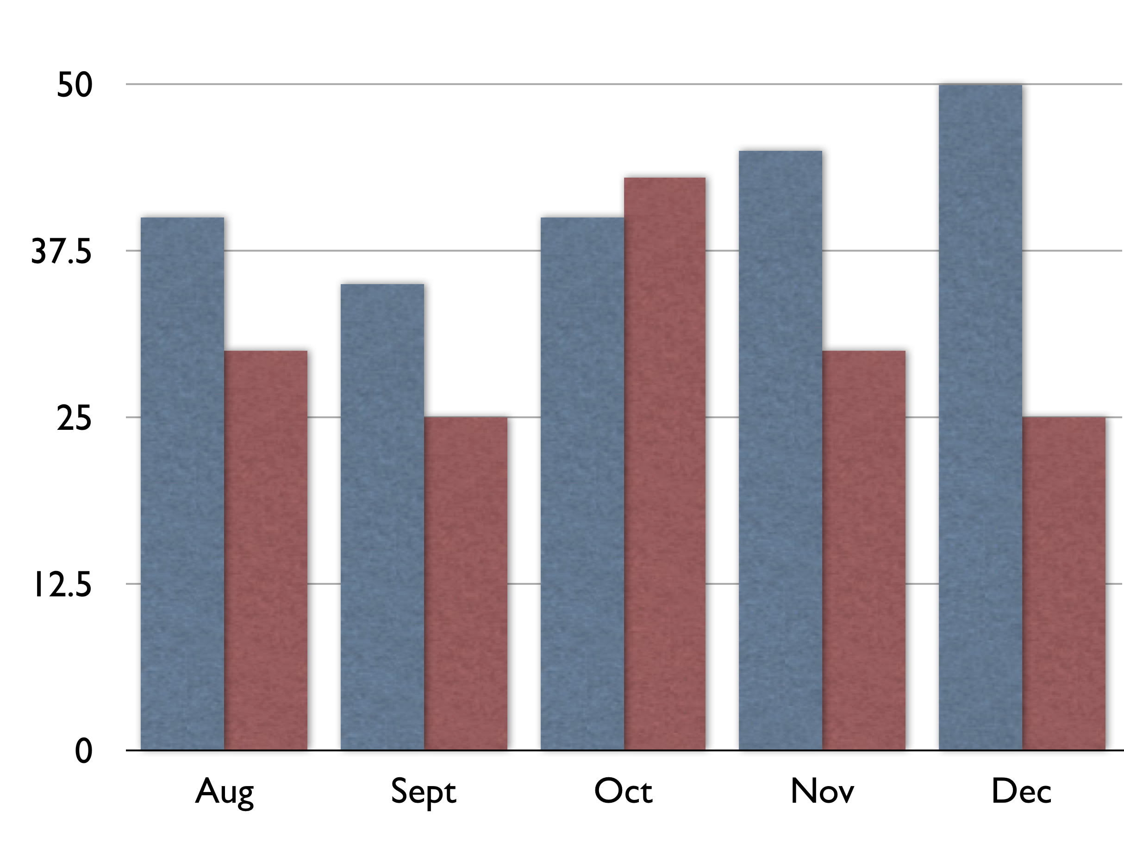
2011
2012

Check out our office referral data for classroom disruptions compared to last year.

As you can see, the rate is reduced for all months except October. But after our November booster, the rates went down again. Great work team!

Overall, our office data referrals have decreased 35% compared to this same time last year. So continue using our Behavior Flowchart consistently and fill out the referral form completely.

- Mr. Jones, principal and the PBIS Team

Email to Staff

Hey Panther Nation,

Here is a quick update for the month of September:

- 85% of students have NO tardies and 92% have NO office referrals

- 98% of staff and 95% of students completed our climate surveys

- Results of surveys and office data graphs are posted at myPBIS.org/panthers

- Click these links to like our Facebook, Twitter, and SchoolTube pages.

- What do you think of our students’ newest video?
Make a comment and share your feedback!

- Mrs. Jones, principal and the PBIS Team

Letter to Local Newspaper

Big News at Washington Elementary School!

This year Washington, led by principal Bev Early, is using a school-wide Positive Behavior Interventions and Supports (PBIS) system to decrease disruptive behaviors so that all students can excel.

All students are taught the 3 Bee’s – Be Respectful, Be Responsible, and Be Caring. These expectations are taught in the classroom, cafeteria, playground, and bus. All students who are caught demonstrating these expectations are given a ‘Bee Proud’ ticket. Drawings are held weekly to recognize students for their positive behavior.

Look at the school-wide results in academics and behavior for the past two years in the chart below. It clearly shows that since Washington Elementary began using PBIS in 2011, both academics and behavior have improved.

Teachers report dramatically less classroom disruptions, leading to increased time for teaching. Student report fewer incidents of bullying and violence on and off campus. And parents have called the school to report how pleased there that their students are recognized for outstanding character!

It’s a win-win for our community. To see more , visit the school’s PBIS website at www.myPBIS.org/washington .

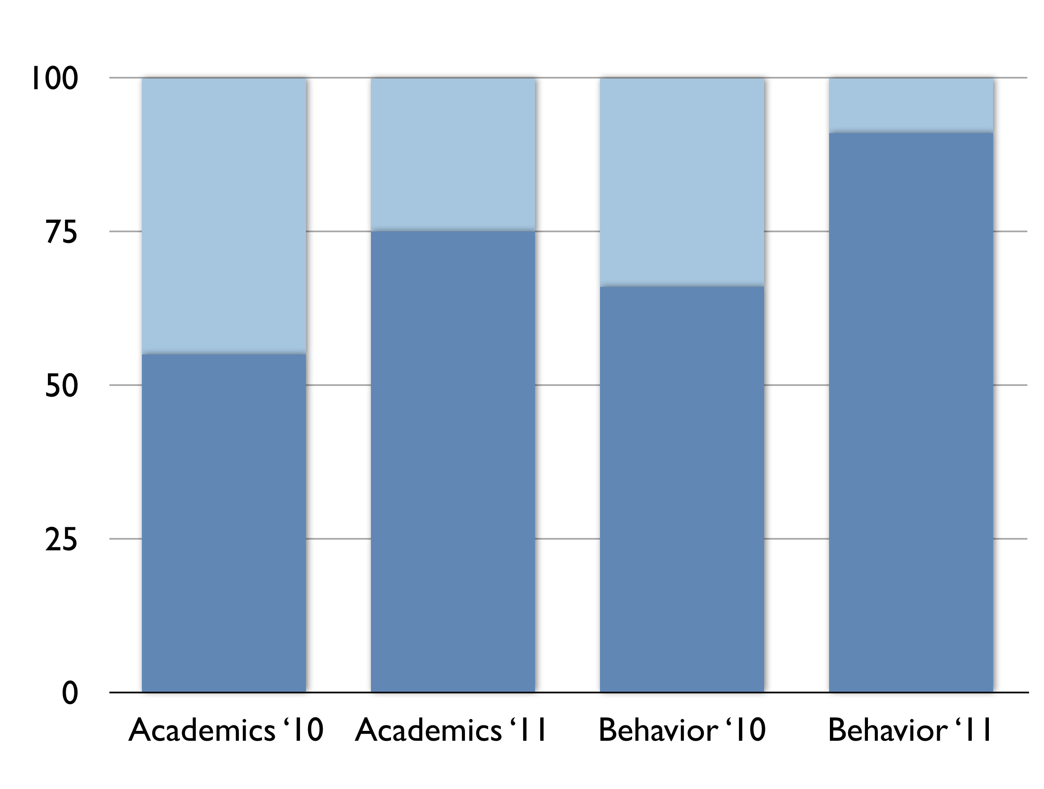
At-Risk Student’s

Excelling Student’s

